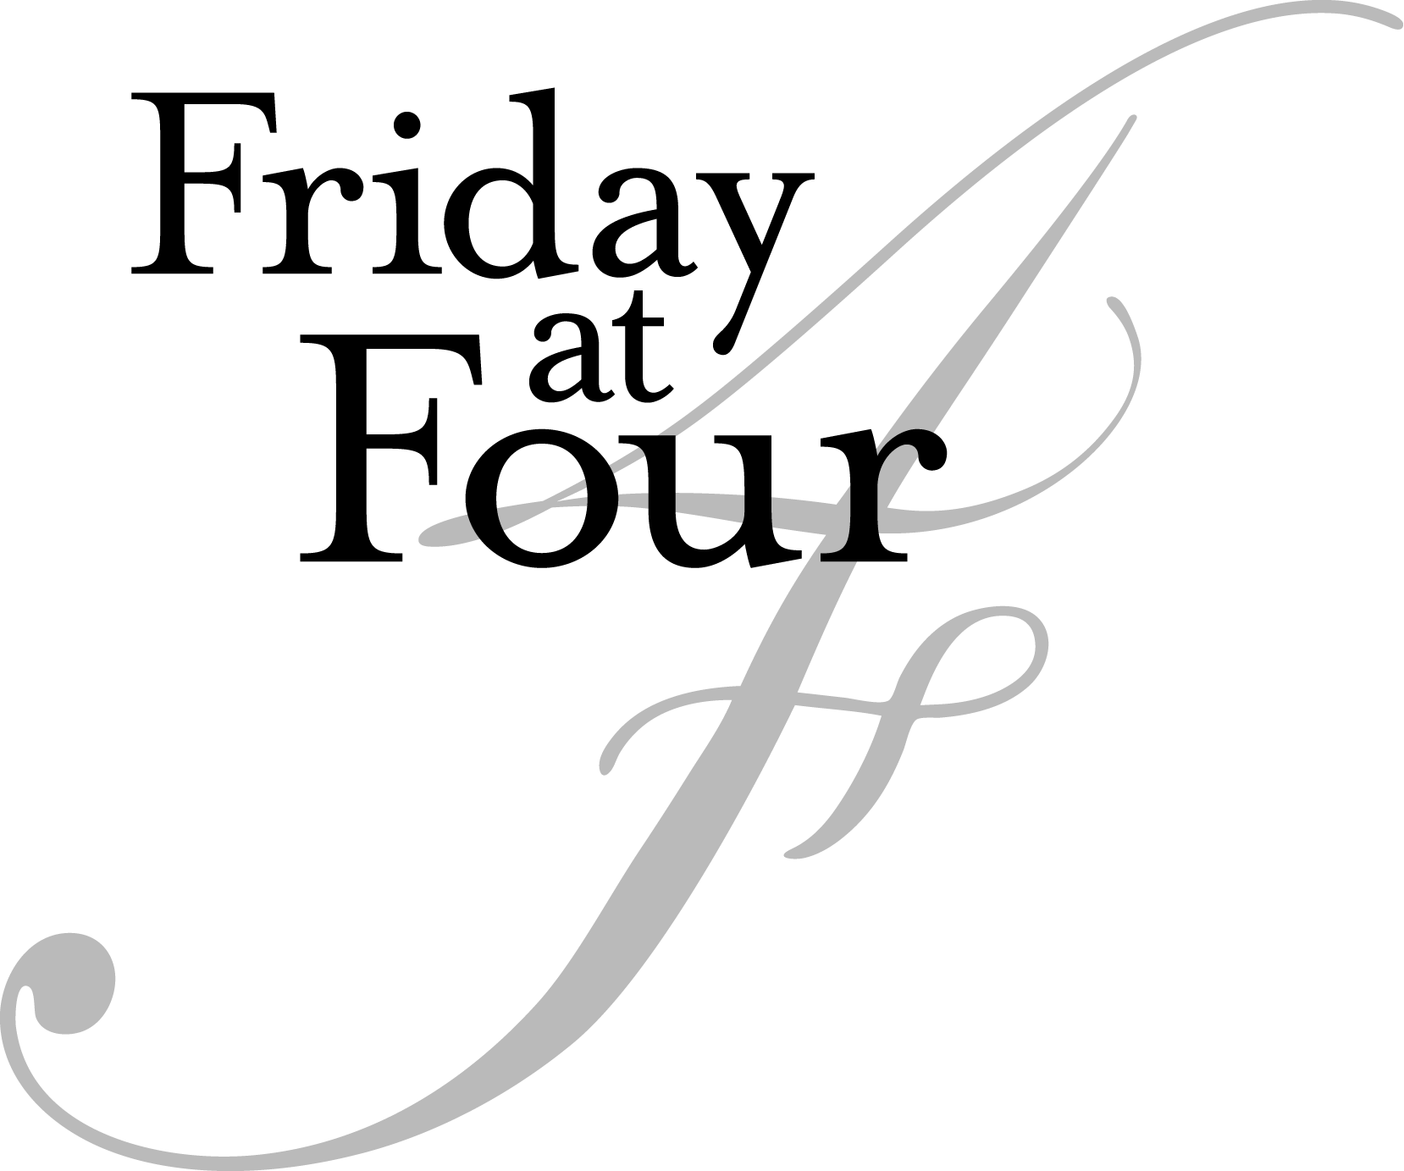

MARCH 11, 2016

Eliot Hall Chapel
4:00 p.m.

Sonata for viola and piano, Op. 147 Dmitri Shostakovich (1906-1975)
II. Allegretto
Clio Goldstein, viola
Denise VanLeuven, piano

La Courte Paille Francis Poulenc (1899 – 1963)
Le Sonnmeil
La reine de cœur
Le carafon
K Newton, mezzo soprano (physics, ’16)
Will Holdhusen, piano (physics, ’16)

Si Mes Vers Avaient Des Ailes Reynaldo Hahn (1874 – 1947)
Pie Jesu Gabriel Fauré (1845-1924)
Elliot Menard, soprano
John Vergin, piano *

Verborgenheit Hugo Wolf (1860- 1903)
Das Verlassene Mägdlein Hugo Wolf
Die Nacht Richard Strauss (1864-1949)
Morgen! Richard Strauss
Emily Curtis, soprano (religion, ’16)
Max Eisendrath, piano

Romanze, Op.85 Max Bruch (1838-1920)
Maia Scarpetta, viola (psychology, ’16)
Max Eisendrath, piano

- Music performance staff

Le sommeil (Sleep)

Sleep is on vacation.
My God! Where has it gone?
I've rocked my little one in vain;
he cries in his crib,
he's been crying since noon.
Where has sleep put
its sand and its wise dreams?
I've rocked my little one in vain;
he turns, all sweaty,
he sobs in his bed.

Ah! return, return, sleep,
on your beautiful race horse!
In the black sky, the Big Bear
has buried the sun
and re-lit his bees
If baby doesn't sleep well,
he won't say "good morning,"
he won't say anything tomorrow
to his fingers, to the milk, to the bread
that greet him with the day.

La reine de cœur (Queen of Hearts)

Softly leaning
on her window-panes of moon,
the queen gestures to you
with and almond flower.
She is the Queen of Hearts.
She can, if she wishes,
lead you in secret
into strange dwellings
where there are no more doors,
or rooms, or towers,
and where the young dead
come to talk of love.

The queen salutes you;
hasten to follow her
Into her hoar-frost castle
with smooth stained-glass moon windows.

Le carafon (The baby carafe)
"Why," lamented the carafe,
"couldn’t I have a baby carafe?
At the zoo, Mrs. Giraffe-
doesn’t she have a baby giraffe?"
A wizard who was riding by
astride a phonograph
recorded the beautiful
soprano voice of the carafe
and played it for Merlin.
"Very well," said he, "very well!"
He clapped his hands three times
-And the lady of the house
still asks herself why
-And the lady of the house
still asks herself why
she found, that morning,
a pretty little baby carafe
leaning up against the carafe
just as in the zoo, the baby giraffe
leans its long and fragile neck
against the smooth flank of the giraffe.

Si Mes Vers Avaient Des Ailes

My verses would flee, soft and frail,
Toward your oh so beautiful garden,
If my verses had wings,
Like the bird.
They would fly, sparks,
Toward your entrance that laughs,
If my verses had wings,
Like the spirit.
Close to you, pure and faithful,
They would hasten, night and day,
If my verses had wings,
Like love.

Verborgenheit (Secrecy)

Tempt me not, o world, again
lure me not with joys that perish,
let my heart, unspoken, cherish
all its rapture, all its pain.

Unknown grief consumes my days,
'tis with eyes all veiled by sorrow
that, when dawns each hopeless morrow,
on the glorious sun I gaze.

Only dreaming brings me rest
only then a ray of gladness,
sent from Heaven, cheers my sadness
lights the gloom within my breast.

Tempt me not, o world, again
lure me not with joys that perish,
let my heart, unspoken, cherish
all its rapture, all its pain.

Das Verlassene Mägdlein (The Forsaken Maiden)

Early, when the cock crows,
before the stars disappear,
I must stand at the hearth;
I must light the fire.

Beautiful is the blaze of the flames;
the sparks fly.
I gaze into the fire,
sunk in grief.

Suddenly, it comes to me,
unfaithful boy,
that last night
I dreamed of you.

Tears upon tears then
pour down;
So the day comes -
O would it were gone again!

Die Nacht (Night)
Night steps out of the woods,
And sneaks softly out of the trees,
Looks about in a wide circle,
Now beware.

All the lights of this earth,
All flowers, all colors
It extinguishes, and steals the sheaves
From the field.

It takes everything that is dear,
Takes the silver from the stream,
Takes away, from the cathedral’s copper
The gold.

The shrubs stand plundered,
Draw nearer, soul to soul;
Oh, I fear the night will also steal
You from me.

Morgen! (Morning)
And tomorrow the sun will shine again,
And on the path that I will follow,
It shall again unite us, happy ones,
Upon this sun-breathing earth...
And to the wide shore, with its blue waves,
We will quietly and slowly descend,
Speechless, we shall look into each other's eyes,
And upon us will descend the muted silence of happiness.

UPCOMING MUSIC EVENTS:

Friday @ Four, April 1, 4 P.M., Eliot Chapel. Emily Curtis, soprano assisted by Max Eisendrath, piano

Friday@ Four, April 8, 4 P.M., PAB Performance Lab
Adrian Boctor, senior composition thesis recital.

